Lego, Value, and the Purpose of Business and Work

“Try not to become a man of success. Rather become a man of value.”

― Albert Einstein

Around the turn of the century, Lego was in trouble. They had lost their way. Revenue and earnings looked like this:

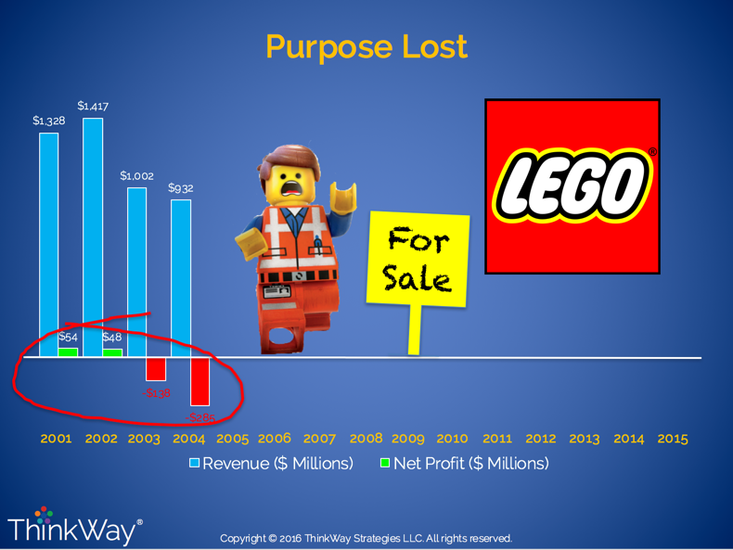

Through a series of events which reconnected them with their core purpose of creating value for their consumers, Lego made an historic turnaround and now things look like this:

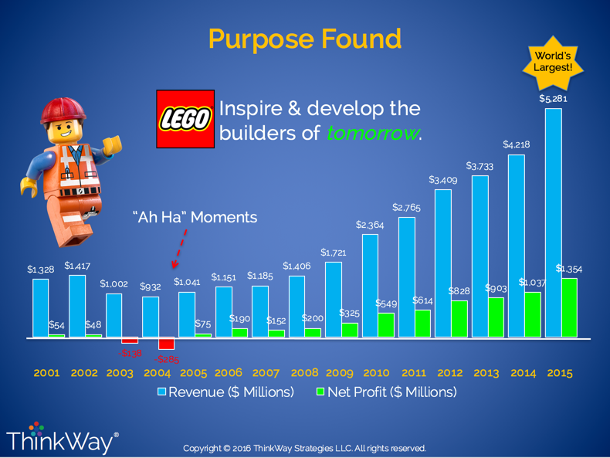

At speaking engagements or when I speak to people in business privately, most get it wrong. They think the purpose of business is about making money. But Peter Drucker said it well, “Profit is not the purpose of business. Rather, it’s the test of its validity.”

The purpose of work or your business is not money, success or the pursuit of some sort of significance. Rather, the purpose of work and business is the creation and free exchange of value that meets and serves the needs of others.

Ultimately, your success depends on your attention to the needs of others and your understanding and focus on creating value that can meet those needs. That’s what Lego did to orchestrate one of the most storied turnarounds in business history. They got back to their core value creation focus: toy bricks and the joy, skill, and inspiration those little bricks could bring.

The purpose of your work, your business, is not money. It’s value creation.